PRE-K - KINDERGARTEN 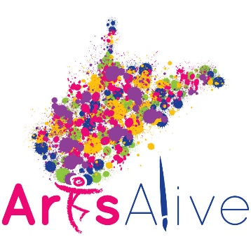
A vital, integrated part of the Art Exhibit at Arts Alive 2019 will be the artwork of pre-k and kindergarten students…truly young artists! Each county will select rich visual art pieces from your county’s Universal Pre-K and Kindergarten classrooms. Remember that young children’s artwork:
a) focuses on process, not product;
b) may or may not be “something;”
c) needs a title for the work;
d) should provide opportunity to work with various media and
e) should be created using developmentally appropriate practices (open-ended art).

- Note that no pre-made craft items will be accepted.
- To ensure the exhibit provides the most accurate information about the child, media used, and process of creation, complete the document titled PRE-K and Kindergarten Submission Form 2019 for the piece of artwork submitted by your County Collaborative Early Childhood Team.
- Mail this form along with the child’s artwork to Dr. Raymond Lowther (see address below).
- Artwork will be returned to the student or County Pre-K Coordinator/Contact if indicated on Submission Form.
- We will arrange to have all 2D artwork gallery matted and shrink wrapped for the Arts Alive! Exhibit. 3D work will be securely and professionally displayed.
- If you have questions about PRE-K submissions, please contact Rhonda Fisher rffisher@k12.wv.us or Dr. Raymond Lowther rlowther@k12.wv.us.
All work must be received on or before March 1, 2019. .
Mail artwork to:
Dr. Raymond Lowther
West Virginia Department of Education
Office of Middle / Secondary Learning
Building 6, Room 620
1900 Kanawha Boulevard East
Charleston, WV 25305-0330

